# TASK NO.1

Get shipper’s Company Name for an order using inner join. (Display only orderID from orders and comapnayName from Customers table)

# QUERY

select o.customerid, cus.companyName from orders o inner join customers cus on o.customerid = cus.customerid

# OUTPUT

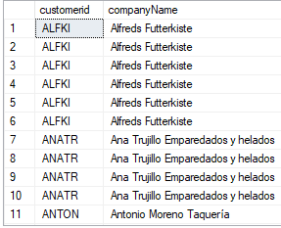

# TASK NO.2

Display Product’s name and their supplier’s name (ContactName), whose supplier’s name doesnot contain Dirk and there should be at most 7 characters in Product’s name.

# QUERY

select p.productname, s.contactname from products p inner join suppliers s on s.supplierid = p.supplierid where s.contactname not like '%dirk%' and p.productname like '_______'

# OUTPUT

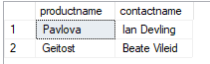

# TASK NO.3

Create a report showing order ID,OrderDate. EmployeeID, and the firstname and LastName of the associated Employee (Tables: Employees & Orders )

# QUERY

select o.orderid, o.EmployeeID,o.orderdate,em.FirstName,em.LastName from Orders o inner join Employees em on o.EmployeeID=em.EmployeeID

# OUTPUT

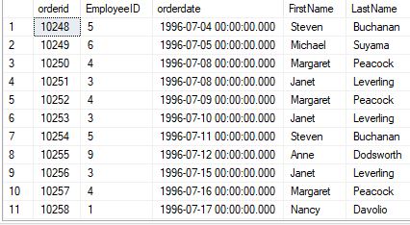

# TASK NO.4

Count no of Products’s against each suppliers name. list only those products whose count is greater than 3.

# QUERY

select count(p.productname) as productNamezz, s.contactname from products p inner join suppliers s on s.supplierid = p.supplierid group by s.contactname having count(p.productname) > 3

# OUTPUT

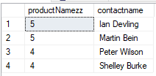

# TASK NO.5

Display Region ID, Region Description, Territories Description and (inner join with table Territories and Region)

# QUERY

select r.regionid,r.regiondescription,t.territorydescription from region r inner join territories t on r.regionid=t.regionid

# OUTPUT

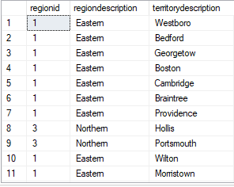

TASK NO.6

Display Company Name and Total orders placed by the company (Table: orders, customer, use inner join, group by)

# QUERY

select count(o.orderid)as Total_Orders,c.companyname from Orders o inner join Customers c on o.CustomerID=c.CustomerID group by c.companyname

OUTPUT

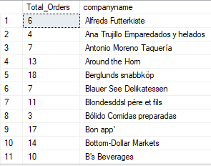

TASK NO.7

Display Product Name and its Category Name where Category Name starts with B (Hint: Left join category and product, use wild card)

QUERY

select c.categoryname,p.productname from categories c left join Products p on c.CategoryID = p.CategoryID where c.CategoryName like 'b%'

# OUTPUT

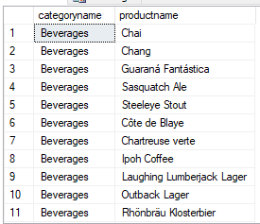

# TASK NO.8

Display Titles and their quantity (Hint Pubs database, table title and sales, left join)

# QUERY

select t.title,s.qty from titles t left join sales s on t.title_id=s.title_id

# OUTPUT

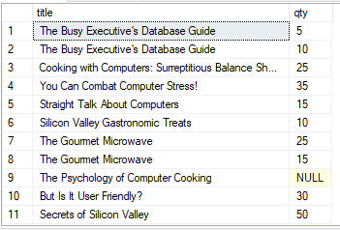

# TASK NO.9

Use Right join to display Book Title and publisher Names (Hint pubs Database, Table Title and Publisher) Write down the reason for any null values if coming in title column.

QUERY

select t.title,p.pub_name from titles t right join publishers p on t.pub_id=p.pub_id

the reason behind null is that there is no match from left table (title)

# OUTPUT

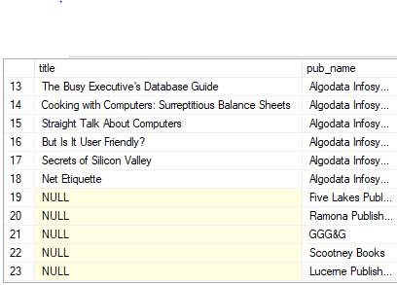

# TASK NO.10

User Right join to display those publishers where title is null.

# QUERY

select t.title,p.pub_name from titles t right join publishers p on t.pub_id=p.pub_id where t.title is null

# OUTPUT

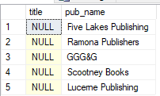

# TASK NO.11

Use self-join to display Publishers name where city is same (Publisher id should be different)

# QUERY

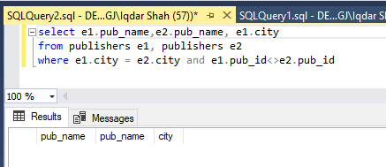

# OUTPUT



# TASK NO.12

Use cross join (Cartesian join) to Display Book Title and Publisher Name.

# QUERY

select t.title,p.pub_name from titles t cross join publishers p

# OUTPUT

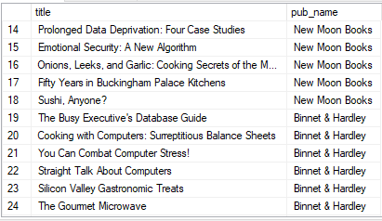

# TASK NO.13

Use two full joins to Display Product Name, Category Name and Supplier Name

# QUERY

select p.ProductName, s.CompanyName , c.CategoryName from Products p full join Suppliers s on p.SupplierID=s.SupplierID full join Categories c on p.CategoryID = c.CategoryID

# OUTPUT

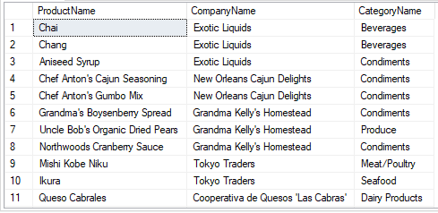

# TASK NO.14

Use full join to display the name of Supplier for the product starting with letter C (Hint: Northwind)

# QUERY

select p.ProductName, s.CompanyName from Products p full join Suppliers s on p.SupplierID=s.SupplierID where p.ProductName like 'c%'

# OUTPUT

